Keegan Moynahan *** Worked on with Steph

Lab 7

Q1) n=123

require(palmerpenguins)

dat_pen = subset(penguins, species != "Adelie")

dat_pen2 = subset(dat_pen, species != "Chinstrap")

# Choose significance level

alpha = 0.05

# 2: Calculate sample standard error:

n = sum(!is.na(dat_pen2$bill_length_mm))

print(n)

Q2) sd = 0.0898

Gent_sd = sd(!is.na(dat_pen2$bill_length_mm))

print(Gent_sd)

Q3) t value = 1.9796

t_crit = abs(qt(alpha / 2, df = n - 1))

print(t_crit)

Q4) sse = 0.2779

sse = sd(dat_pen2$bill_length_mm, na.rm = TRUE) / sqrt(n)

print(sse)

Q5) lower 0.4418 upper 1.5420

# Choose significance level

alpha = 0.05

# 2: Calculate sample standard error:

n = sum(!is.na(dat_pen2$bill_length_mm))

sse = sd(dat_pen2$bill_length_mm, na.rm = TRUE) / sqrt(n)

# 3: Calculate critical t-values:

t_crit = abs(qt(alpha / 2, df = n - 1))

# 4: Calculate the CI radius:

ci_radius = sse * t_crit

# The CI is the sample mean +/- the radius:

anst_ci = c(

lower = mean(!is.na(dat_pen2$bill_length_mm)) - ci_radius,

upper = mean(!is.na(dat_pen2$bill_length_mm)) + ci_radius)

print(round(anst_ci, 4))

Q6) lower = 46.96917 upper = 48.06098

Q7)

require(boot)

boot_mean = function(x, i)

{

return(mean(x[i], na.rm = TRUE))

}

myboot =

boot(

data = dat_pen2$bill_length_mm,

statistic = boot_mean,

R = 10000)

print(myboot)

Q8)

str(myboot)

gent_mean = mean(!is.na(dat_pen2$bill_length_mm))

print(gent_mean)

myboot$t0

mean(myboot$t) - myboot$t0

sd(myboot$t)

quantile(

myboot$t,

c(0.025, 0.975))

Q9)

# This clears the current R session's environment

rm(list = ls())

# Re-read my data:

moths = read.csv(here("data", "moths.csv"))

moth_dat = moths[,-1]

rarefaction_sampler = function(input_dat, n_iterations)

{

n_input_rows = nrow(moth_dat)

results_out = matrix(

nrow = n_iterations,

ncol = n_input_rows)

n = nrow(moth_dat) #number of rows or sample observations

m = 10000 #number of bootstrap iterations

moth_result = matrix(

nrow = m,

ncol = n)

# The outer loop: runs once for each bootstrap iteration. index variable is i

for(i in 1:n_iterations)

{

# The inner loop: simulates increasing sampling intensity

# Sampling intensity ranges from 1 site to the complete count of

# sites in the input data (n)

for(j in 1:n)

{

# sample the input data row indices, with replacement

rows_j = sample(n, size = j, replace=TRUE)

# Creates a new data matrix

t1 = input_dat[rows_j, ]

# Calculates the column sums

t2 = apply(t1, 2, sum)

# Counts the number of columns in which any moths were observed

results_out[i, j] = sum(t2 > 0)

}

}

return(results_out)

}

rarefact = rarefaction_sampler(moth_dat, 10000)

head(rarefact)

Q10) The most difficult part of building the function was trying to figure out where to put the assigned values that made the code run. At first I thought we needed to re-build the top of the function but after looking at what was already there I realized all I needed to do was just assign the values before they were being used in the function. After that it was obvious why they were needed.

Q11)

moths = read.csv(here("data", "moths.csv"))

rarefact = rarefaction_sampler(moths[,-1], 10000)

rare_mean = apply(rarefact, 2, mean)

rare_quant = apply(rarefact, 2, quantile, probs=c(0.025, 0.975))

rare = t(rbind(rare_mean, rare_quant))

matplot(

rare,

type='l',

xlab='Number of sampling plots',

ylab='Species richness',

main="Mike's Awesome Rarefaction Curve")

Q12)

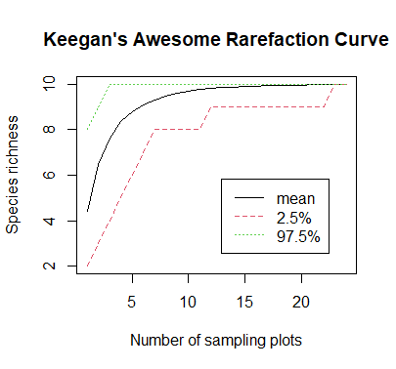

Q13) I would say 20 sites because the mean and majority of the data end at the20. You would also see most of the species between 0 and 10.